

**Stage 3**

**Nagham Thamer Al-Otaibi**

**202110560**

**Kinda Suleiman Aldardese**

**202110811**

**Maya Amjad Salsaa**

**202110124**

**Context Diagram:**

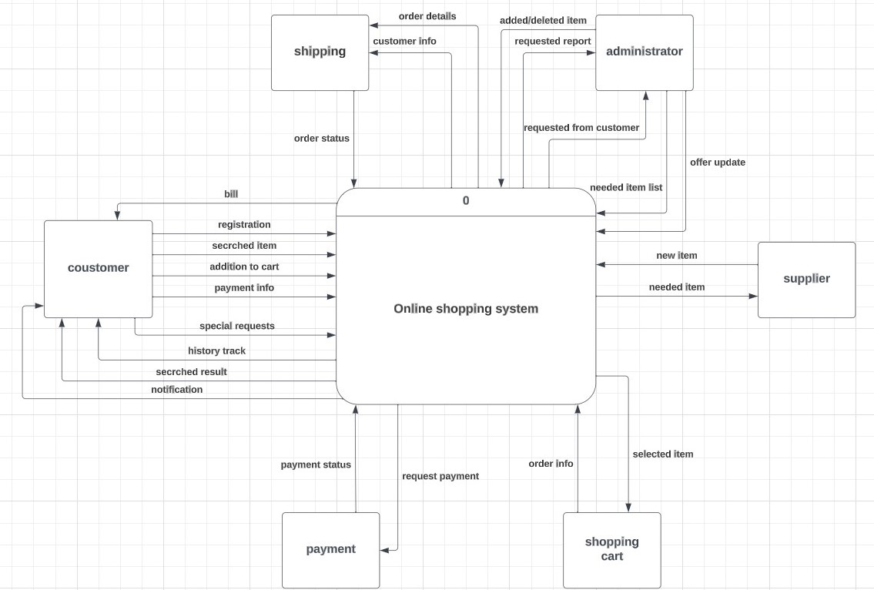

**Level-zero Diagram:**

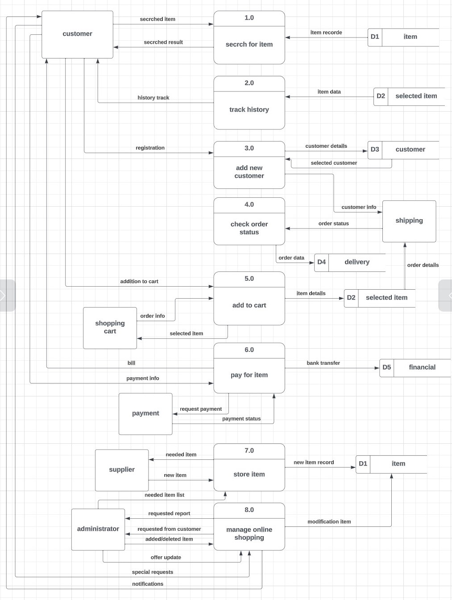

**Child Diagram:**

**Child Diagram for Process 1.0: (Diagram 1)**

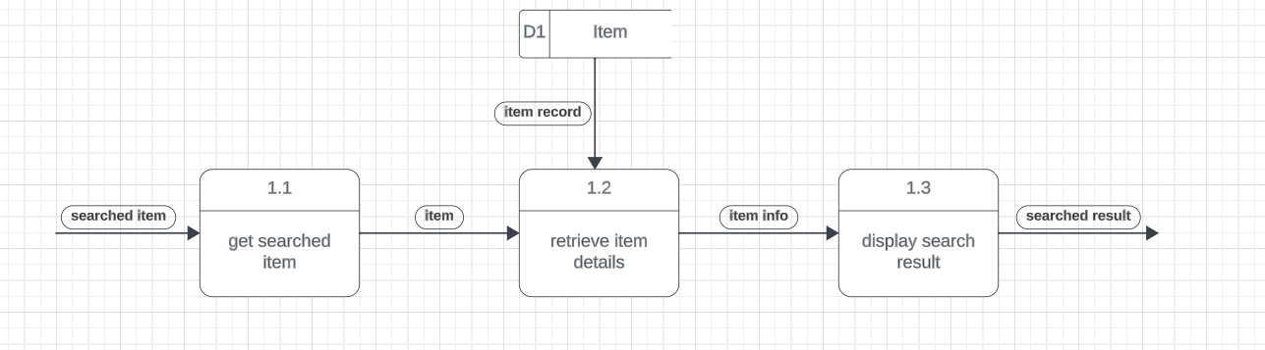

**Child Diagram for Process 3.0: (Diagram 3)**

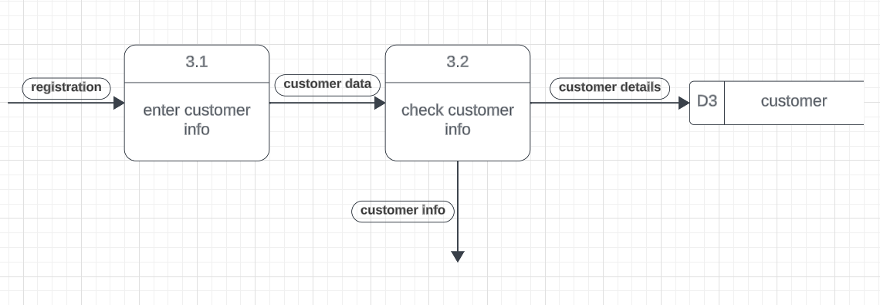

**Dictionary:**

|  |
| --- |
| **Data Store Description Form**  **ID:**  **D3**  **Name:** **customer**  **Alias: client**  **Description:**  **contains customer information that stores in customer table (D3)**  **Customer = customer_name + customer_Id + (address) + {tel} +email** |
| **Data Store Characteristics**  **File Type Computer Manual**  **File Format Database Indexed Sequential Direct**  **Record Size (Characters): 3000 Block Size: 9KB**  **Number of Records: Maximum 30000 Average 2000**  **Percent Growth per Year: 10 %** |
| **Data Set Name tblcustomer**  **Copy Member customer_name , customer_Id, address , tel , email**  **Data Structure customer**  **Primary Key customer_Id**  **Secondary Keys email**  **Comments:** |

|  |
| --- |
| **Data Store Description Form**  **ID:** **D1**  **Name:**  **item**  **Alias: product**  **Description:**  **contains item information that stores in item table (D1)**  **item (item_name , item_Id , quantity , warehousing_info , price)** |
| **Data Store Characteristics**  **File Type Computer Manual**  **File Format Database Indexed Sequential Direct**  **Record Size (Characters): 1000 Block Size: 8KB**  **Number of Records: Maximum 30000 Average 2000**  **Percent Growth per Year: 4 %** |
| **Data Set Name tblitem**  **Copy Member item_name , item_Id , quantity , warehousing_info , price**  **Data Structure item**  **Primary Key item_Id,**  **Secondary Keys warehousing_info**  **Comments:** |

|  |  |
| --- | --- |
| **Data Structure Description Form**  **Name:** **Supplier**  **Alias:** **Vendor**  **Description:**  **the administration is transmitting a list to the supplier. This list serves as a detail of the specific items required. The supplier then takes action, leveraging this list as a guide to procure and deliver the specified items. where the supplier's role is to bring forth new things that align precisely with the list's specifications. This symbiotic approach underscores a seamless and efficient interaction** | |
| **Related data flows/structures**   * **New item** * **Needed list item** * **Needed item** | **Volume/Time**  **10/day** |
| **Data Structure:**  **Supplier =** **Supplier_name + Supplier_Id + {tel} +email** | |
| **Comments:** | |
| **Data Structure Description Form**  **Name: Customer**  **Alias: Client**  **Description:**  **customers initiate item requests. The system captures these requests, including item details and any specific requirements. Subsequently, the system seamlessly transmits these requests to the administrators** | |
| **Related data flows/structures**  **registration** | **Volume/Time**  **45 / day** |
| **Data Structure:**  **Customer = customer_name + customer_Id + address + {tel} +email** | |
| **Comments:** | |

|  |  |  |
| --- | --- | --- |
| **Data Flow Description**  **ID:** **1**  **Name:** **searched item**  **Description:**  **The user searches for a product to see if it is available in the system or not** | | |
| **Source**  **customer** | **Destination**  **Process 1.0** | |
| **Type of Data Flow**  **File Screen Report Form Internal** | | |
| **Data Structure Traveling with the Flow**  **item** | | **Volume/Time**  **100/day** |
| **Comments:** | | |

|  |  |  |
| --- | --- | --- |
| **Data Flow Description**  **ID:** **2**  **Name:**  **order info**  **Description:**  **User selects an item to purchase. The details of the selected item are sent and added to the basket, and the basket sends the data to the system** | | |
| **Source**  **shopping cart** | **Destination**  **Process 5.0** | |
| **Type of Data Flow**  **File Screen Report Form Internal** | | |
| **Data Structure Traveling with the Flow**  **order** | | **Volume/Time**  **100/day** |
| **Comments:** | | |

|  |  |  |
| --- | --- | --- |
| **Data Flow Description**  **ID:** **3**  **Name:**  **bill**  **Description:**  **Calculating the amount of the items chosen by the customer and the method of payment** | | |
| **Source**  **Process 6.0** | **Destination**  **customer** | |
| **Type of Data Flow**  **File Screen Report Form Internal** | | |
| **Data Structure Traveling with the Flow**  **payment** | | **Volume/Time**  **40/day** |
| **Comments:** | | |

|  |  |
| --- | --- |
| **Element Description Form**  **ID:** **1**  **Name:** **customer_Id**  **Alias:** **client_id**  **Alias: customerNumber**  **Description:**  **Uniquely identified the customer record (Primary key of the customer table)**  **This ID is automatically assigned by the system.** | |
| **Related data flows/structures**  **Length 9(8) Dec. Pt. 0 Alphabetic**  **Input Format 9(8) Alphanumeric**  **Output Format 9(8) Date**  **Default Value Numeric**  **Continuous or Discrete Base or Derived** | |
| **Validation Criteria** | |
| **Continuous**  **Upper**  **Limit 99999999**  **Lower**  **Limit 0** | **Discrete**  **Value Meaning** |
| **Comments:** | |
| **Element Description Form**  **ID: 2**  **Name: tel**  **Alias: mobileNum**  **Alias: phoneNumber**  **Description:**  **The customer can put more than one phone number so that we can reach him easily, and they must be unique numbers** | |
| **Related data flows/structures**  **Length 9(**10**) Dec. Pt. 0 Alphabetic**  **Input Format 9(**10**) Alphanumeric**  **Output Format 9(**10**) Date**  **Default Value Numeric**  **Continuous or Discrete Base or Derived** | |
| **Validation Criteria** | |
| **Continuous**  **Upper**  **Limit**  **Lower**  **Limit** | **Discrete**  **Value Meaning**  **+962 Jordanian num**  **+971 Emirati num** |
| **Comments:** | |

|  |  |
| --- | --- |
| **Element Description Form**  **ID:** **3**  **Name:** **price**  **Alias: cost**  **Alias: expense**  **Description:**  **The administrator sets the price and then the system calculates the invoice** | |
| **Related data flows/structures**  **Length 9(7) Dec. Pt. 0 Alphabetic**  **Input Format 9(7) Alphanumeric**  **Output Format 9(7) Date**  **Default Value Numeric**  **Continuous or Discrete Base or Derived** | |
| **Validation Criteria** | |
| **Continuous**  **Upper**  **Limit**  **Lower**  **Limit** | **Discrete**  **Value Meaning**  **EUR Euro**  **USD Dollar**  **JOD Jordanian dinar** |
| **Comments:** | |